**Snowflake Git Setup and Deployment process**

1. Create ‘Snowflake’ github repository.
2. Create EC2 instance for running the Github workflow.
3. Associate the EC2 instance to Elastic IP.
4. Whitelist the elastic IP address of EC2 instance in snowflake.
5. Go to repo setting ->General🡪Action🡪Runners

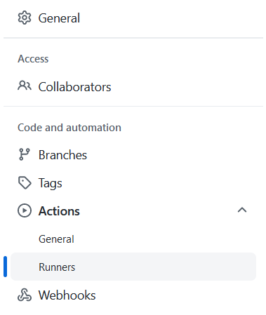

1. Click on ‘New self hosted runner’ and run the scripts provided by Github on the runner instance.

After which you can see the instance details on the Github settings runners page.

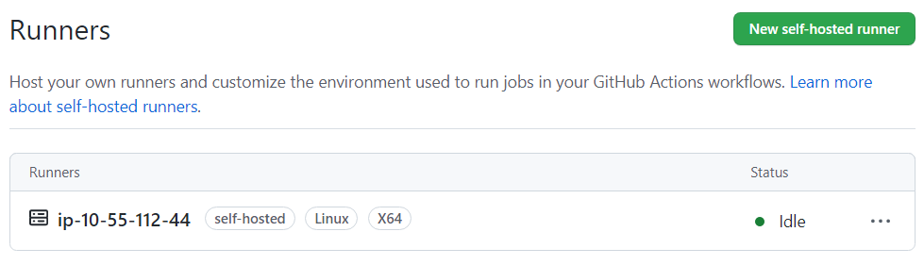

1. Create migrations/tables, migrations/views folder in the repo.
2. Place the SQL script to be executed in Snowflake in below format. Do increase the version every time new script is to be executed.

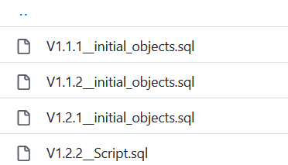

1. Go to Action and create ‘New workflow’. This will create blank yaml file.

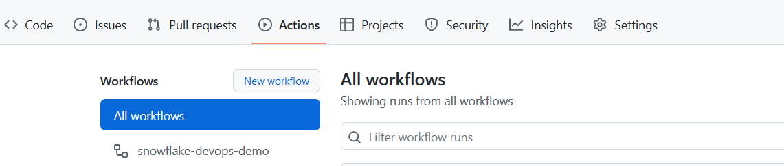

1. Update the blank yaml file with the attached code in txt file.



1. Go to Settings 🡪 Secrets🡪Action and create action secret keys for the parameters as in screenshot.

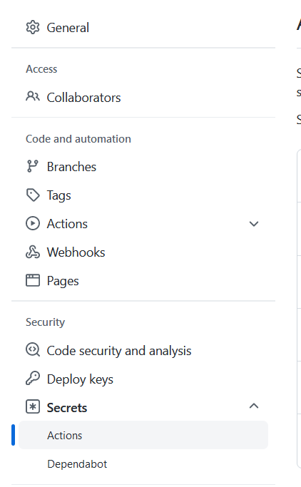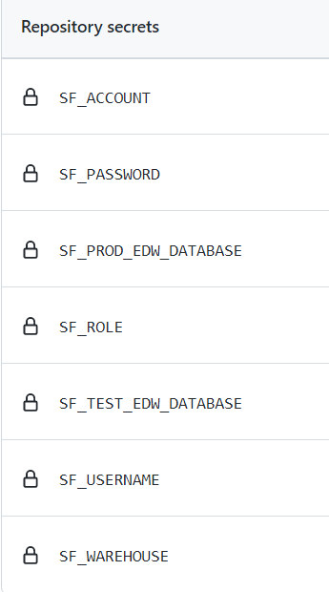

1. Add SQL script in the migration folder under tables or view folder of repository and run the workflow based on the branch on which the code is pushed to snowflake repository. This will deploy the code into the respective database.

